Task 1: Dataset-Verified Design

1. Conceptual ER model
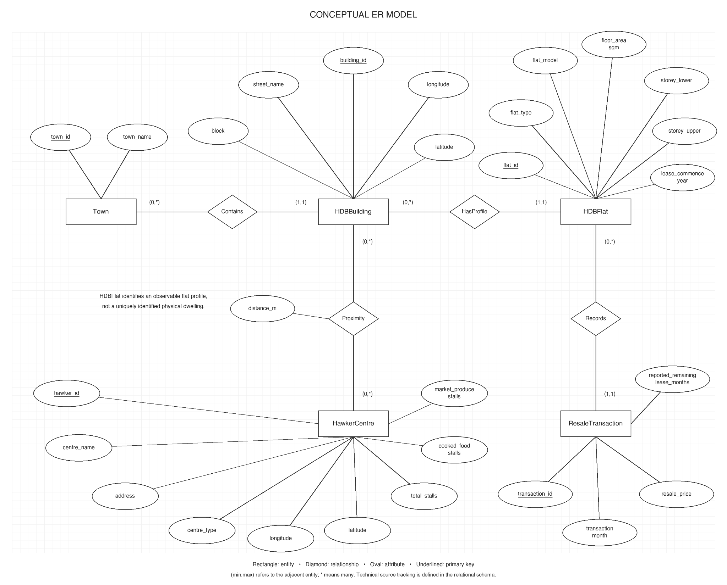

2. Relational schema
Following W4, five entity tables and four relationship tables are first identified. The three 1:N relationships are merged into their many-side tables; the M:N Proximity relationship remains a separate table. The result is six base relations. Underlining denotes the primary key, arrows denote foreign keys, and ? denotes nullable.
Town(town_id, town_name)
HDBBuilding(building_id, town_id → Town, block, street_name, longitude?, latitude?)
HDBFlat(flat_id, building_id → HDBBuilding, flat_type, flat_model, floor_area_sqm, storey_lower, storey_upper, lease_commence_year)
ResaleTransaction(transaction_id, flat_id → HDBFlat, transaction_month, resale_price, reported_remaining_lease_months?, source_sha256, source_row_number)
HawkerCentre(hawker_id, centre_name, address?, centre_type?, longitude?, latitude?, total_stalls?, cooked_food_stalls?, market_produce_stalls?)
BuildingHawkerDistance(building_id → HDBBuilding, hawker_id → HawkerCentre, distance_m)
The two underlined distance-table attributes form one composite key. Alternate keys are town_name; (block,street_name); the complete flat-profile combination; and (source_sha256,source_row_number). The source hash and row number are loading metadata, not raw business fields.
Under the stated FDs, every nontrivial determinant is a superkey, so the base relations satisfy BCNF and therefore 3NF. Closures and minimal keys were checked. Splitting combined transaction/building/town data along their ID dependencies is lossless because each intersection is a key of an extracted relation (W5).

3. Proximity and missing values
Haversine straight-line distances use building and centre coordinates. The chosen classes are Near ≤500 m, Medium >500–1,000 m and Far >1,000 m. These thresholds are a project choice. All valid geocoded pairs are retained; classes are calculated in views.
Q4 assigns each building its nearest centre. Q5 selects its nearest centre with known market_produce_stalls >0. Equal-distance ties use the smaller hawker_id, preventing duplicate transaction counts. The supplied centre cohort includes market-only sites; centre_type supports an explicit alternative filter if the team chooses one.
Years-only leases in 2015–2016 are converted to months with year precision disclosed; 2017-onward year/month strings are parsed into total months. Pre-2015 leases remain unknown: Q2 needs an UNKNOWN bucket or a clearly disclosed reported-only cohort.
（For example:
Block | Street | Hawker ID | Distance KM | ProximityClass
866 | Jurong West St 81 | 1 | 0.6 | Near
866 | Jurong West St 81 | 2 | 1.2 | Medium
866 | Jurong West St 81 | 3 | 2.1 | Far
Why not choose other distance calculation methods?
）

4. Table connections
Arrows point from FK to referenced PK. The distance bridge implements the building-to-centre M:N relationship; descriptive attributes are omitted from this overview.

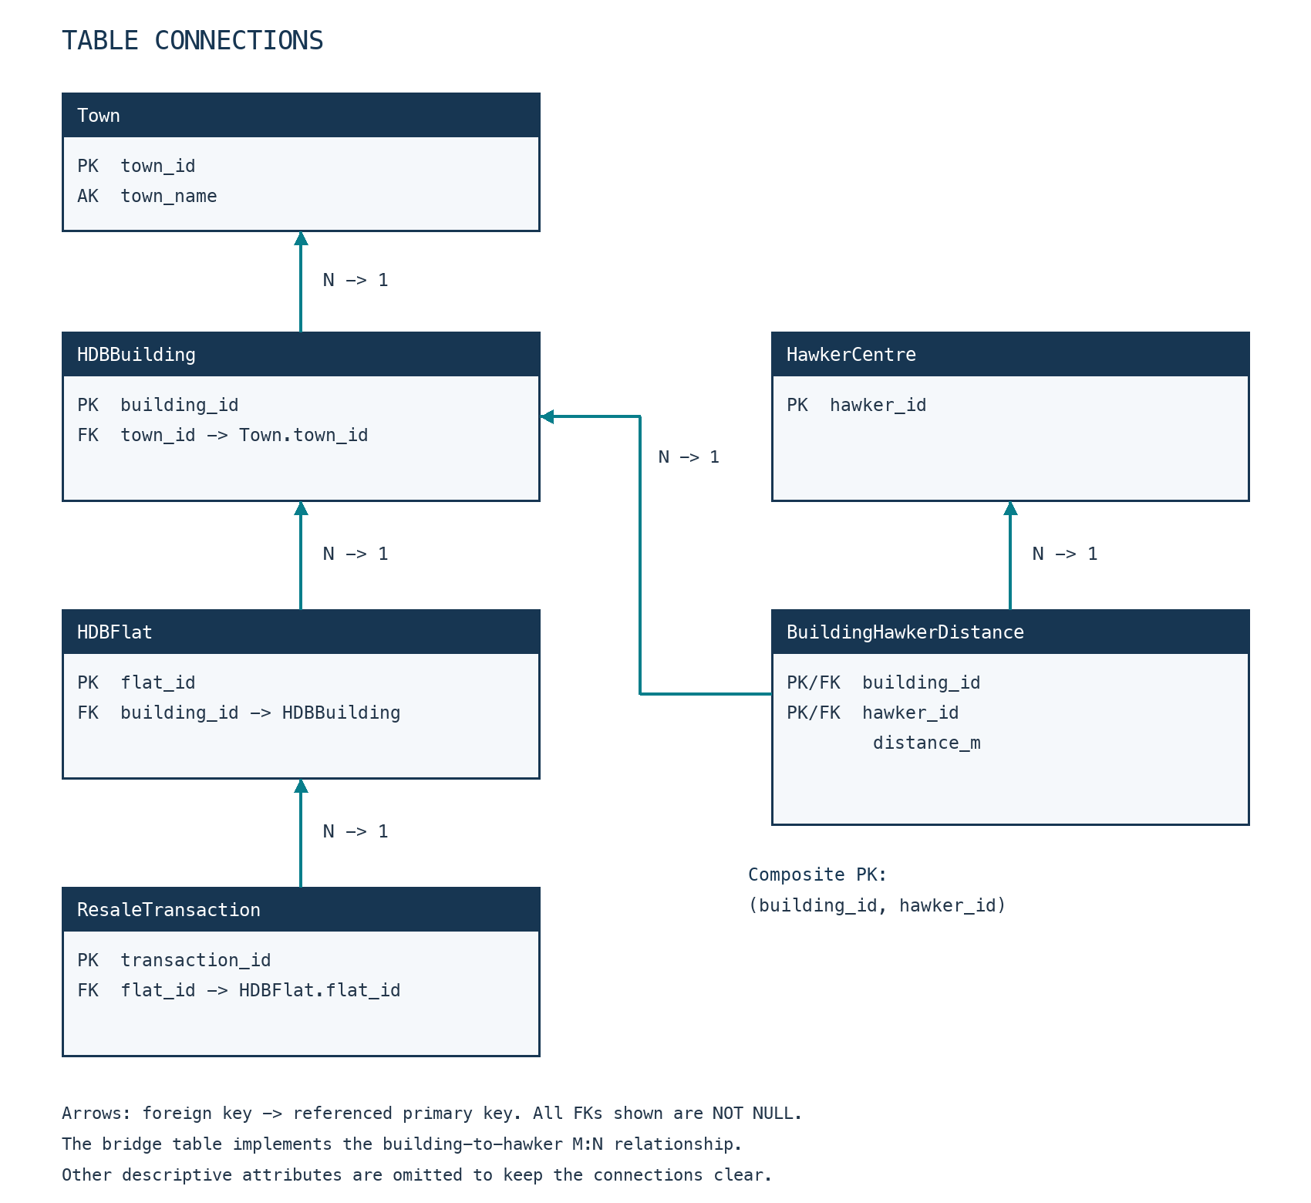

5. SQL and validation
See in the SQL Scripts

